VANNE H.P 2 VOIES BOISSEAU

VALVOLA A SFERA A 2 VIE
VANNE 2 VOIES BSP FEMELLE ISO228
BKHG

2-WAY BALL VALVE
2-WEGE KUGELHAHN

RS 2
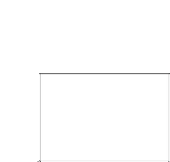
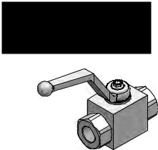

 |  |  |  |  |  |  |  |  |  | L2
 |  |  |  |  |  |  |  |  |  |  |  |  |  |  |  | L2
 |  |  |  |  |  |  |  |  |  |  |  |  | H1
 |  |  |  |  |  |  |  |  |  |  |  |  |  | A |  | P |  |  | H | H1
 |  |  |  | A |  |  |  |  |  | P |  | L3 | H |  |  |  | L3
A |  |  |  |  |  |  | L |  |  |  |  |  | S |  | L
 |  |  |  |  |  |  |  |  |  |  |  |  | S |  |  |  |  | S
 |  |  |  |  |  |  | L1 |  |  |  |  |  |  |  | L1
P |  |  |  |  |  |  | RS2 |  |  |  |  |  |  |  | RS2B
 |  |  |  |  |  |  |  |  |  | Q |  | P
Code |  |  |  | A - P |  |  | Schéma |  |  | MAX |  | MAX | Type |  | L | L1 | L2 | L3 | H | H1 | S | kg
. |  |  |  | BSP |  |  |  |  |  | l/min |  | bar
FBBKHG00104 |  |  |  | 1/4" |  |  | -- |  |  | 25 |  | 500 | RS 2 | DN 6 | 42,4 | 71 | 110 | 14,5 | 35 | 91,5 | 30 | 0,50
FBBKHG00106 |  |  |  | 3/8" |  |  | -- |  |  | 35 |  | 500 | RS 2 | DN10 | 44,4 | 73 | 110 | 17,4 | 40 | 96,5 | 35 | 0,65
FBBKHG00108 |  |  |  | 1/2" |  |  | -- |  |  | 60 |  | 500 | RS 2 | DN13 | 48,4 | 83 | 110 | 18 | 43 | 99,5 | 37 | 0,77
FBBKHG00112 |  |  |  | 3/4" |  |  | -- |  |  | 100 |  | 400 | RS 2 | DN20 | 62,5 | 95 | 180 | 23,4 | 55 | 106,5 | 45 | 1,46
FBBKHG00116 |  |  |  | 1" |  |  | -- |  |  | 160 |  | 350 | RS 2 | DN25 | 66,5 | 112 | 180 | 29,5 | 65 | 116,5 | 55 | 2,23
FBBKHG00220 |  |  |  | 1"1/4-R |  |  | -- |  |  | 160 |  | 350 | RS 2 | DN25 | 66,5 | 120 | 180 | 29,5 | 65 | 116,5 | 55 | 2,30
FBBKHG00224 |  |  |  | 1"1/2 |  |  | -- |  |  | -- |  | 350 | RS 2B DN40 |  | 85 | 131 | 300 | 53,5 | 107 | 134,5 | 102 | 7,39
FBBKHG00232 |  |  |  | 2" |  |  | -- |  |  | -- |  | 350 | RS 2B DN50 |  | 98 | 140 | 300 | 57 | 114 | 141,5 | 118 | 9,05
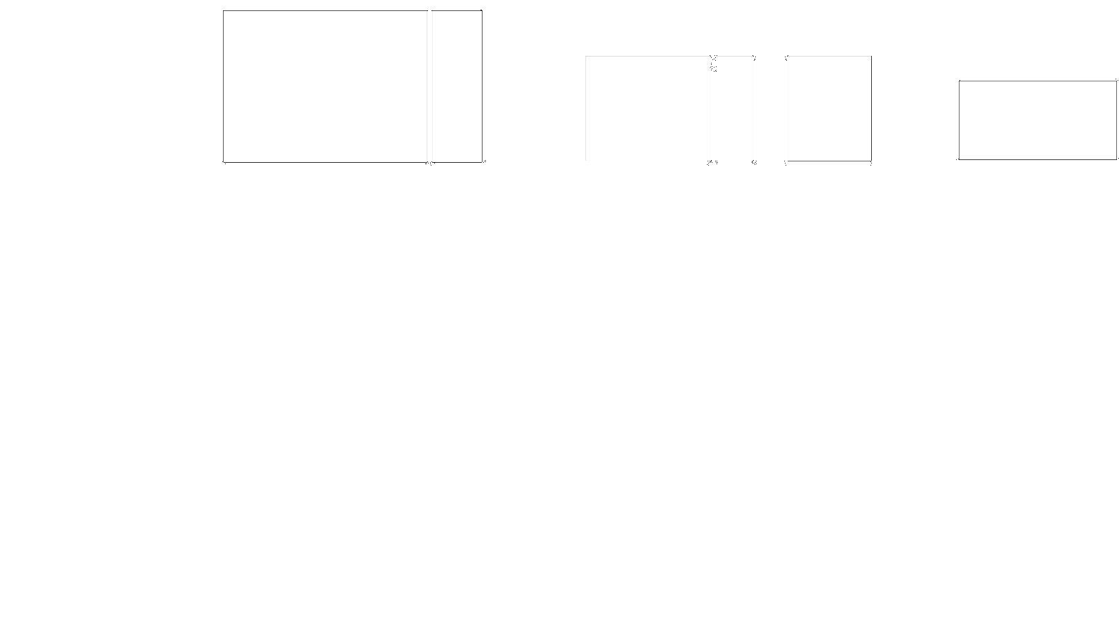
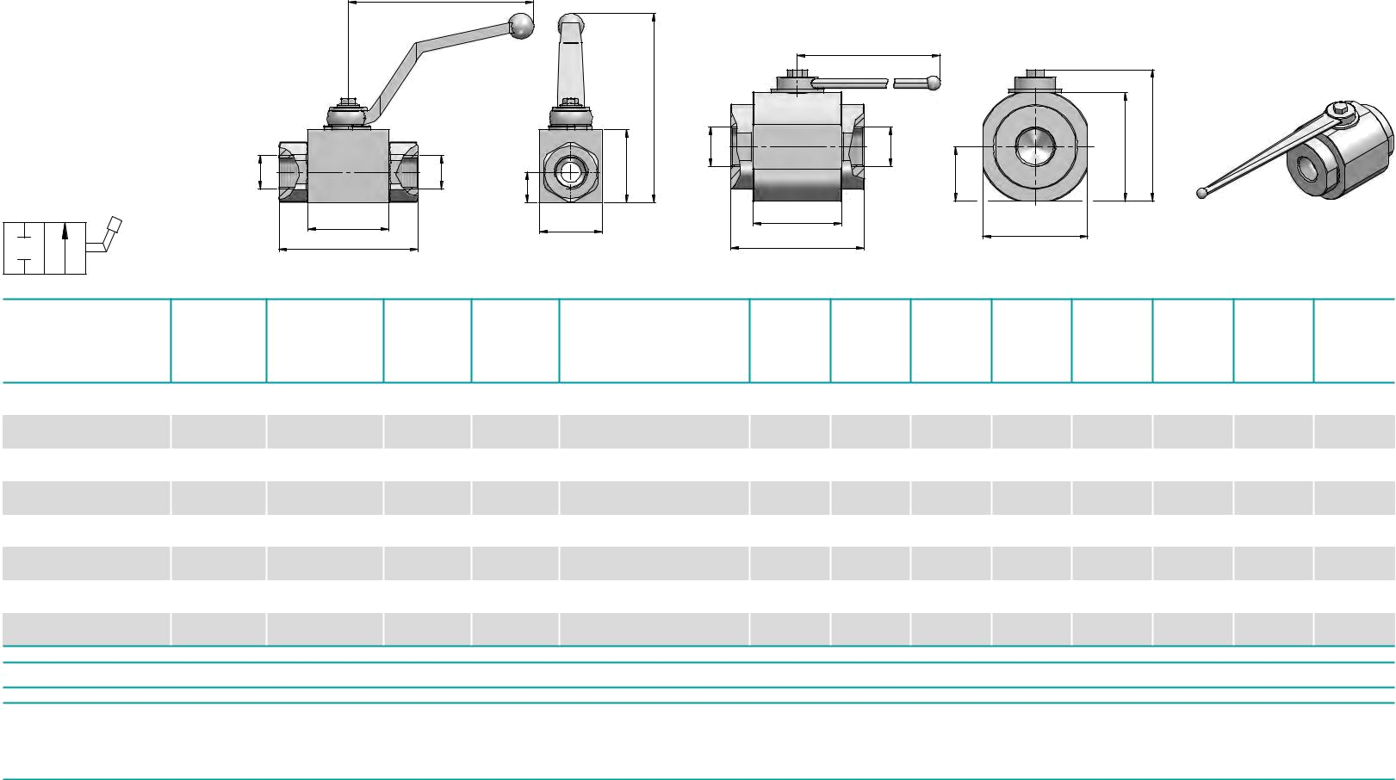

VANNES 02 VOIES H.P SERIE L
BKHL
VALVOLA A SFERA A 3 VIE - CENTRO CHIUSO

3-WAY BALL VALVE - CLOSED CENTRE
3-WEGE KUGELHAHN - GESCHLOSSENE RUHESTELLUNG

RS 3/L
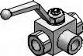

L2
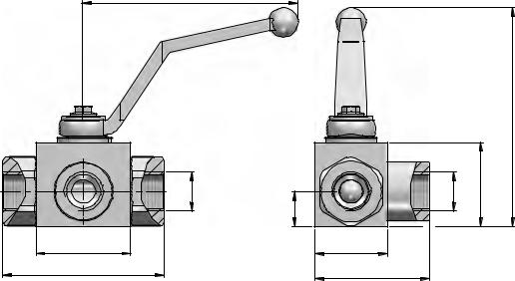

 |  |  |  |  |  |  |  |  |  | L2
 |  |  |  |  |  |  | H1
 |  |  |  |  |  |  |  | A |  | B |  |  | PH | H1
 | A |  | B |  |  |  | PH |  |  |  | L3
 |  |  |  | L3
0ºA B 90º |  | L |  |  | S |  |  |  | L |  |  | S
 |  | L1 |  |  | S1 |  |  |  | L1
P |  | RS3/L |  |  |  |  |  |  | RS3B/L
 | P |  | Q | P
Code | A - B | Schéma | MAX | MAX |  | Type |  | L | L1 | L2 | L3 | H | H1 | S | S1 | kg
 | BSP |  | l/min | bar
FBBKHL0010 | 1/4" | L | 25 | 400 | RS | 3/L | DN 6 | 42,4 | 71 | 110 | 14,5 | 35 | 91,5 | 30 | 48,5 | 0,54
FBBKHL0012 | 3/8" | L | 35 | 400 | RS | 3/L | DN10 | 44,4 | 73 | 110 | 17,4 | 40 | 96,5 | 35 | 54,5 | 0,70
FBBKHL0015 | 1/2" | L | 60 | 350 | RS | 3/L | DN13 | 48,4 | 83 | 110 | 18 | 43 | 99,5 | 37 | 58,5 | 0,83
FBBKHL0018 | 3/4" | L | 100 | 350 | RS | 3/L | DN20 | 62,5 | 95 | 180 | 23,4 | 55 | 106,5 | 45 | 75 | 1,58
FBBKHL0022 | 1" | L | 160 | 350 | RS | 3/L | DN25 | 66,5 | 112 | 180 | 29,5 | 65 | 116,5 | 55 | 87,5 | 2,42
FBBKHL0028 | 1"1/4-R | L | 160 | 350 | RS | 3/L | DN25 | 66,5 | 120 | 180 | 29,5 | 65 | 116,5 | 55 | 87,5 | 2,60
FBBKHL0035 | 1"1/2 | L | -- | 350 | RS 3B/L DN40 |  |  | 85 | 131 | 300 | 53,5 | 107 | 134,5 | 115 | - | 8,63
FBBKHL0042 | 2" | L | -- | 350 | RS 3B/L DN50 |  |  | 98 | 140 | 300 | 57 | 114 | 141,5 | 128 | - | 10,61

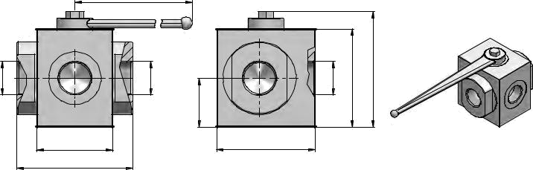

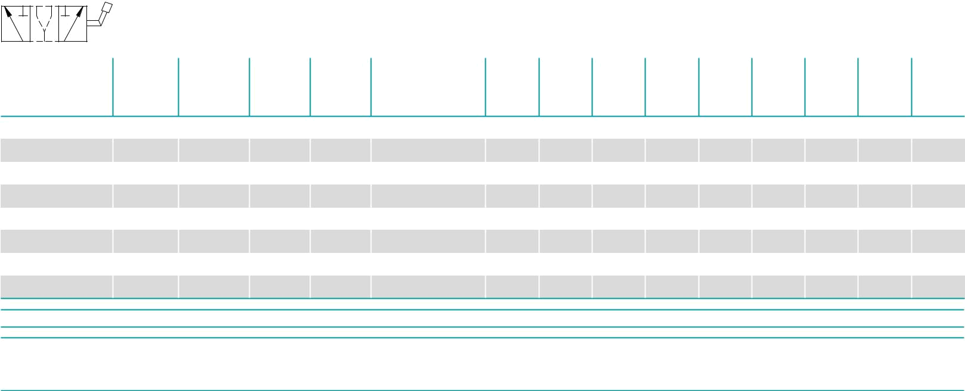

Adresse lot 12 hectares rue « B » N 17 BBA Email : contact@flexibordj.com Site www.flexibordj@live.com
MOB 0770959812/0770281512 TEL/FAX 035723795

